|  |  |  |  |
| --- | --- | --- | --- |
|  | Bansilal Ramnath Agarwal Charitable Trust's  Vishwakarma Institute of Information Technology  **Department of**  **Artificial Intelligence and Data Science** | | |
| Name: Siddhesh Dilip Khairnar | | | |
| Class: SY | Division: B | | Roll No: 272028 |
| Semester: IV | | Academic Year: 2022-2023 | |
| Subject Name & Code: Probability and Statistics: ES22201AD | | | |
| Title of Assignment: Calculating the probability of accident | | | |
| Date of Performance: 30-01-2023 | | Date of Submission: 06-02-2023 | |

**PAS Experiment- 2**

**Background information:**

To calculate the probability of an accident, you need to know the number of accidents that have occurred in a given time period and the total number of opportunities for an accident to occur during that same time period. The probability of an accident is then simply the number of accidents divided by the total number of opportunities.

For example, let's say you are interested in the probability of a car accident occurring on a particular stretch of road during a given month. You could gather data on the number of car accidents that occurred on that road during the month, as well as the total number of cars that drove on the road during that same month. Let's say you found that there were 10 car accidents during the month and 10,000 cars drove on the road during that same month. The probability of a car accident occurring on that road during the month would be:

P(accident) = number of accidents / total number of opportunities

P(accident) = 10 / 10,000

P(accident) = 0.001

So, the probability of a car accident occurring on that road during the month is 0.001 or 0.1%.

It's important to keep in mind that this is a simplified example and that there may be many factors that affect the probability of an accident, such as weather conditions, road conditions, driver behavior, and more. Additionally, calculating probabilities for complex systems or events may require more sophisticated statistical methods.

**Program and Output:**

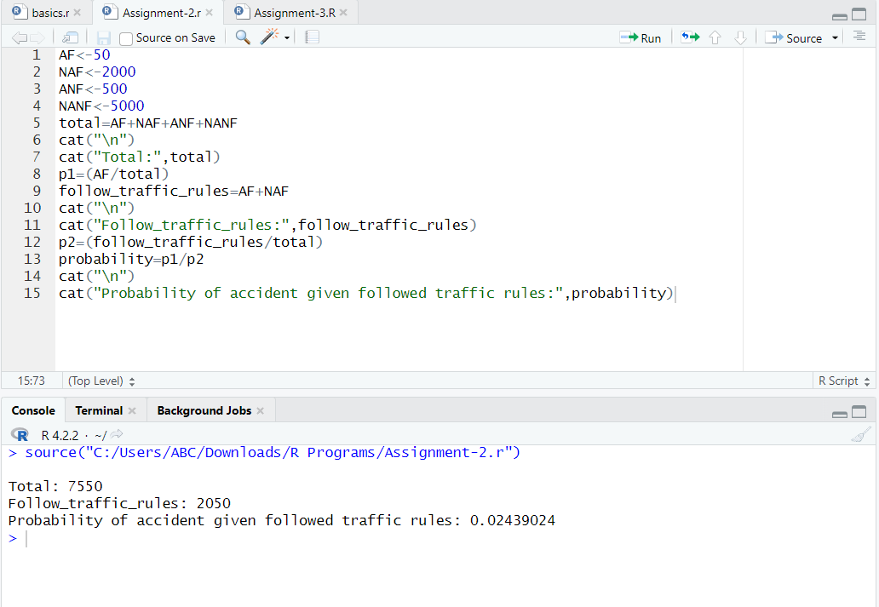

**Conclusion:** Thus, we have introduced R instructions for probability operation and also calculated probability for the given PS.